Project Management Plan

Harmony Resources 12-05-2024

# Document Control

## Registry

|  |  |
| --- | --- |
|  | **Information** |
| Date | *12-05-2024* |
| Version | *1.0* |
| Refª ProJet: | *GRUPO15* |
| File Name | *Project Management Plan* |

## Versions History

|  |  |  |  |
| --- | --- | --- | --- |
| **Version** | **Date** | **Change** | **Author (sigla)** |
| *[1.0]* | *[12-05-2024]* | *[Section, Page(s) and Text Revised]* |  |
| *[2.0]* | *[19-05-2024]* | *[New WBS chart, new ornagogram and text revised]* | *João, César* |
|  |  |  |  |

## Project Team

|  |  |  |
| --- | --- | --- |
| **Role** | **Name©** | **Nº mec** |
| Project Manager | João Santos | 8220256 |
| Team Member | Sónia Oliveira | 8220114 |
| Team Member | Hugo Guimarães | 8220337 |
| Team Member | Pedro Pinho | 8220307 |
| Team Member | César Castelo | 8220169 |

Index

Document Control i

Registry i

Versions History i

Project Team i

Project scope definition 1

Project objectives 1

Product Scope Description 1

Project Requisites 2

Project Limits 3

Project deliverables 4

*Acception Criteria* 4

*Project Restrictions* 4

*Initial organization of the project* 5

*Risks* 5

*Cronogram* 6

*Budget expectative* 6

Budget 6

Work Breakdown Structure (WBS) 7

Diagram 7

Diagram Dictionary 7

Organogram 9

Image Index

Figure 1 – Organizational chart 5

Figure 2 - Project Cronogram 6

Figure 3 - Harmony Resources Diagram 7

Figure 4 - Organogram 9

# Project scope definition

## Project objectives

The Harmony Resources project aims to create an employee management platform for Critical Techworks. Having won the proposal from the company, our group aims to provide a high-quality product that will allow employees of the company to:

- Manage employees – manage employee absenteeism, documents, requests, salaries, and messages among themselves.

- Manage Human Resources - enable, through the platform, the completion of most tasks that human resources previously handled in person.

- Manage training – through the platform, provide the necessary tools to create training sessions, assign trainers to them, and send invitations to employees to participate in them.

These Objectives will be considered as achieved when:

- a group of employees from the client company, for each of the objectives, approve the functionalities developed by the Lilypad development team;

- a total of at least 70% of all of the company’s employees have adopted the platform;

- a total of at least 40% of HR tasks are made in-platform;

- the development schedule for the application is fully complete;

- The client company shows satisfaction with the services provided;

## Product Scope Description

The Harmony Resources project encompasses the development of a comprehensive employee management platform tailored for Critical Techworks. The product will feature the following key characteristics:

* Employee management – as mentioned before, the platform will ease the management of employees, including tracking of attendance features, management of documents, handling of requests to the HR, salary tracking, and internal communication between employees;
* HR Management – it will the streamlining of human resources tasks, allowing for the centralized handling of employee related issues;
* Training Management – the platform will provide robust tools for organizing and administering training sessions.

The scope of the project encompasses all necessary tasks of design, development, testing, and deploy of the platform to meet the desired objectives of the stakeholders.

## Project Requisites

The project requisites outline the detailed specifications and conditions that must be met by the deliverables to satisfy contractual obligations, stakeholder needs, and project objectives.

**Employee Management:**

* **Employee Record:**
  + Implement access control methods for adding employees.
  + Define mandatory fields to prevent incomplete records.
  + Implement duplicate prevention methods.
* **Update Employee Information:**
  + Implement access control for updating employee information.
  + Ensure robust error handling for data inconsistencies.
* **Employee Search:**
  + Implement access control for searching employee information.
  + Allow customization of search results.
  + Ensure data integrity in search results.

**Integration System:**

* **Welcome Resources:**
  + Automatically detect new employees and provide welcome packages.
  + Track integration progress.
* **Employee Handbook and Company Policies:**
  + Provide access to employee handbook and policies.
* **Position-Based Training:**
  + Allow assignment of position-based training.
  + Implement access control for position assignment.

**Request Processing:**

* **Submission of Request:**
  + Allow employees to create requests through the interface.
  + Enforce mandatory fields for request completion.
* **Human Resources Inbox:**
  + Store requests in a centralized database accessible only to HR.

**Training Management:**

* **Training Scheduling:**
  + Allow authorized employees to create training sessions.
  + Implement robust error handling and privacy control.
* **Tracking Training Progress:**
  + Allow viewing of employee training information.
  + Implement access and privacy controls.

**Absenteeism Management:**

* **Recording Entries and Exits:**
  + Integrate with card reader system for employee clock-in/clock-out.
  + Ensure all employees have assigned cards.
* **Request for Absence Justification:**
  + Allow employees to request absence justifications within specified timeframes.
* **Approval of Absence:**
  + Enable HR to approve or deny absence justifications.

## Project Limits

The project is not meant to be a substitute for in person operations of the HR department. More serious matters like the firing of employees, or retirement of the same should still be handled in person.

While the project includes an in-app messaging system, it is not intended to substitute all in-person interactions between employees. Face-to-face meetings and discussions are still encouraged for more complex or formal communication needs.  
  
The message system within app should be used for semi casual, shorter form conversations; the aim of it, is creating a better separation of work and personal life. The objective of the in-app messaging system is allowing employees to have their separate, personal accounts, and phone numbers be separate from their work life.

The project will adhere to all relevant legal and regulatory requirements governing employee data privacy, security, and communication within the app. However, it will not address all legal or compliance matters unrelated to its specific scope and objectives.

## Project deliverables

Delivering requirements

documentation, negotiate

prototype delivery

5/15/2024 - 5/25/2024

Deliver product

prototype (15/6/2024) engage in

primary user training (16/6/2024),

prototype review meeting

(7/20/2024) and discussion on

improvements/changes, post trial

(8/10/2024)

Application Launch 03/02/2025

Training Activities 03/05/2025 -

04/05/2025

## *Acception Criteria*

The Acception criteria has been laid out in the project objectives section of this document.   
The non achievement of the acception criteria will come with consequences, mainly the extension of the work time invested by part of the Lilypad group at no cost to the client.

## *Project Restrictions*

1. Technology Dependencies: There is a risk of encountering compatibility issues with existing systems, potentially delaying the implementation of functionalities.
2. Scope Creep: There is a possibility of additional features or requirements being introduced throughout the project, increasing complexity and potentially extending the timeline and budget. Due to this problem, the scope of the project can’t go over 20% of the initially agreed on requisites.

## *Initial organization of the project*

Figure 1 – Organizational chart

## *Risks*

1. Technology Dependencies: There is a risk of encountering compatibility issues with existing systems, potentially delaying the implementation of functionalities.
2. User Adoption: Employees may resist adopting the new application, leading to low usage and decreased effectiveness of the solution and a failure to measure its effectiveness.
3. Scope Creep: There is a possibility of additional features or requirements being introduced throughout the project, increasing complexity and potentially extending the timeline and budget.

## *Cronogram*

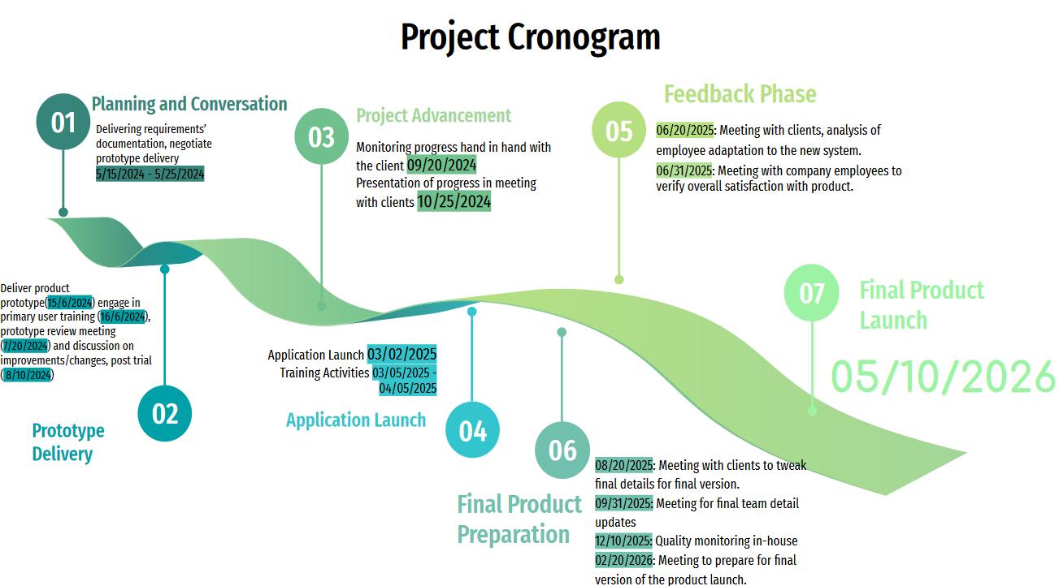

Figure 2 - Project Cronogram

## *Budget expectative*

# Budget

1. **Development Costs:**
   * Personnel Costs: $500,000
   * Software Tools and Licenses: $50,000
   * Hardware Infrastructure: $100,000
   * Training and Documentation: $50,000
2. **Implementation Costs:**
   * Deployment and Integration: $200,000
   * User Training: $100,000
   * Data Migration: $50,000
3. **Operational Costs:**
   * Maintenance and Support: $150,000 per year (for 2 years)
   * Infrastructure Maintenance: $50,000 per year (for 2 years)
   * Continuous Improvement: $100,000
4. **Contingency Reserve:**
   * Risk Management: $100,000

Total Project Budget: $1,450,000

# Work Breakdown Structure (WBS)

## Diagram

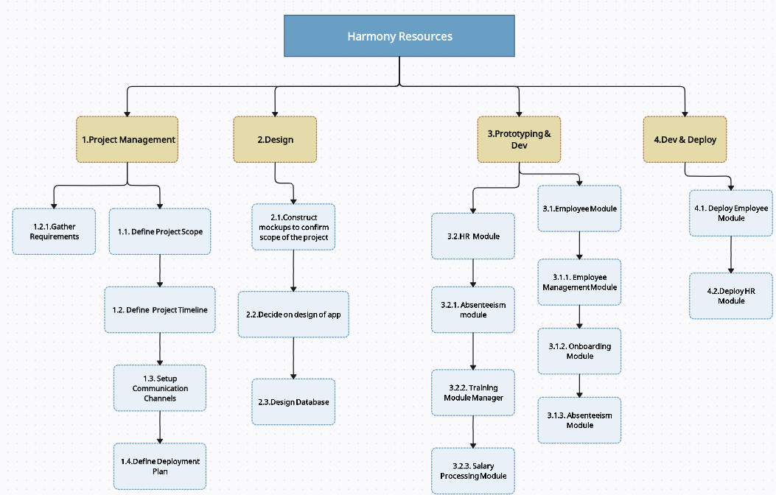

Figure 3 - Harmony Resources Diagram

## Diagram Dictionary

1. **Project Management** - this would be the first section of the project, we will be gathering user stories, requisites, setting up communication channels.
   1. **define project scope** – Determine who will be impacted by the project and who will provide input. Outline goals and desired results of the project. Define how success will be measured.
   2. **define project timeline** – Create Project Roadmap, and sprint schedules.
   3. **setup communication channels** – establish communication tools, set up meeting schedules, define how progress is documented and reported.
   4. **define deployment plan** – define environment and infrastructure, plan deployment phases.
   5. **gather requirements** – Engage with stakeholders to gather user requirements, developed and prioritize them.
2. Design
   1. **decide on app design** – decide on user interface design, visual elements, branding and layout of application;
   2. **construct mockups** – construct mockups to deliver and discuss with shareholders.
   3. **design database** – app architecture. Decide on how information will be stored, structured, and how entities interact between each other.
3. **Prototyping and Development**
   1. **Employee module**
      * 1. **employee management module** – Develop and deliver a general draft of the employee management module, it should include features like the profile of an employee, personalized calendar, inter employee messaging, etc. The draft is to be tested by a set team of selected employees for review.
        2. **onboarding module** – Develop and deliver a general draft of the onboarding module, it should include features as a welcome package, user manuals for new employees and obligatory training. The draft is to be tested by a set team of selected employees for review.
        3. **absenteeism module** - Develop and deliver a general draft of the absenteeism module for employees, it should include features such as a calendar that’ll track attendance of the employee. The draft is to be tested by a set team of selected employees for review.
   2. **HR module**
      * 1. **absenteeism module** - Develop and deliver a general draft of the absenteeism module for human resources, it should include features such as a registry of the attendance of each employee, acessable to human resources employees, it should also include features such as warnings that a human resources employee can apply to a regular employee. The draft is to be tested by a set team of selected employees for review.
        2. **training module** – Develop and deliver a general draft of the training module for human resources, it should include features such as the scheduling of training sessions, assigning trainees, notifying employees assigned through an in-app message, and assigning trainers to the training session. The draft is to be tested by a set team of selected employees for review.
        3. **salary processing module** – Develop and deliver a general draft of the salary procession module for human resources, it should include features such as the recording of salaries that have been paid, through tailored reports. The draft is to be tested by a set team of selected employees for review.
4. **Dev and Deploy**
   1. **deploy employee module** – deploy the final version of the employee module, once all testing and refining is complete in the first of a two-step deployment plan.
   2. **deploy HR module** – deploy the final version of the HR module, once all testing and refining is complete in the first of a two-step deployment plan.

## Organogram

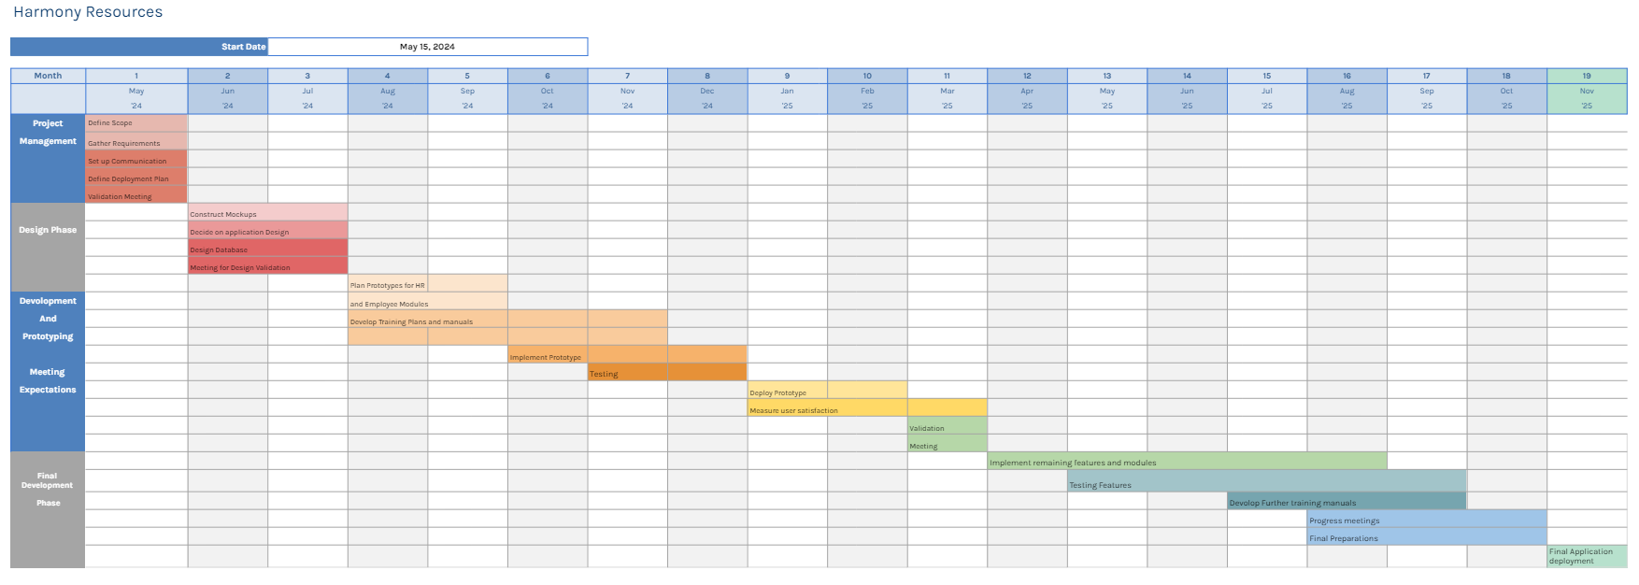

Figure 4 - Organogram

1º Project Management - 15/05/2024 - 29/05/2024

* Define Scope
* Gather requirements
* Set up communication channels
* Define deployment plan

**Meeting for Scope and Requirements Validation: 5/29/2024**

2º Design - 01/06/2024 - 25/07/2024

* Construct Mockups
* Decide on overall design choices of the application
* Design Database

**Meeting for design validation and prototype expectations: 07/28/2024**

3º Prototyping - 01/08/2024 - 01/01/2025

* Plan prototypes for employee and HR modules
* Develop Training plans and user manuals
* Implement prototype
* Testing

**Deploy Prototype: 10/01/2025**

**Begin Prototype user testing, and user satisfaction measurement: 10/01/2025 - 11/03/2025**

**Meeting for quality and expectations met from prototype, gathering suggestions, plan full deployment date - 13/03/2025**

4º - Development and Deployment 13/04/2025 - 10/11/2025

* Implement remaining features and modules
* Testing
* In-House meetings for progress tracking
* Develop further user instruction and training plans
* Deploy final application

**Final application deployment - 15/11/2025**